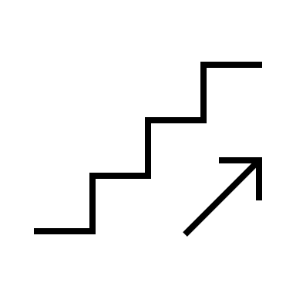
STAIRS
hallway
Conference room
Right again
Right again
Right off elevator
1st right
Keep straight go through auto double doors ahead bear left then right and follow hallway to Cancer Center. Elevator to right. Go to basement
right
Left
Hallway—pass elevators
Main entrance
hallway
Check in
breezeway
Parking deck

